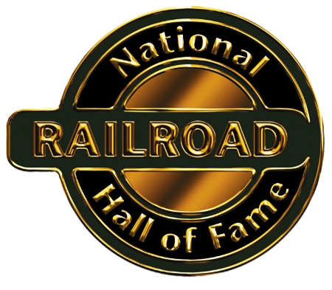
150th Anniversary of the Transcontinental Railroad
Teacher Resources
FOR CLASSROOM USE
Fraser, Mary Ann. Ten Mile Day and the Building of the Transcontinental Railroad. New York, Square Fish/Henry Holt, 2012. On May 10, 1869, the final spike in North America's first transcontinental railroad was driven at Promontory Summit, Utah. Illustrated with the author's carefully researched, evocative paintings, this great adventure story highlights the day Charles Crocker staked $10,000 on the crews' ability to lay a world record ten miles of track in a single day. (One book per 5th grade teacher. A costumed reader may be scheduled for classroom visits.)

Otfinoski, Steven. Building the Transcontinental Railroad: An Interactive Engineering Adventure. North Mankato, Capstone Press, 2015. This "Choose Your Own Adventure"-style book invites readers to assume roles as builders of the Transcontinental Railroad. Readers are asked to flip to different pages based on their choices. Readers will be presented with a realistic view of the human cost of these large-scale projects. Some options end with the death or dismissal of the worker; others result in success and recognition. (Fifteen copies of the book per school for use in partner reading activities. A handout for recording choices will be included.)

Golden Spike Day – A Readers’ Theater Play. This original play by National Railroad Hall of Fame Education Committee Chair, Sheryl Hinman, covers events of May 10th, 1869, from the very personal perspective of characters who were present at the time. The 4-page play has 12 parts (reading level 5.6). A box of simple props and costume accessories will be available to each school for classrooms that would like to read the play on Golden Spike Day.

Linking East and West. This PowerPoint briefly covers the expansion of the West, including
the Pony Express, the Telegraph, and the Transcontinental Railroad. https://www.clover.k12.sc.us/cms/lib/SC01001948/Centricity/Domain/1570/Linking%20East%20and%20West%20Lesson-%20Transcontinental%20RR.pdf

Schulz, Charles M. Charlie Brown – The Building of the Transcontinental Railroad. In this 24-minute video, the familiar Peanuts cartoon characters explain the history of the building of the railroad. It includes maps, music, and photographs. (Note: The online video at the link below contains short commercials. Commercial-free copies may be available at the public library or National Railroad Hall of Fame.) https://www.dailymotion.com/video/x3g8nm0

Costumed Readers – History can come to life in the classroom via our costumed, period actors. Actors will interact with students as they read the exciting, true events depicted in The Ten-Mile Day and The Building of the Transcontinental Railroad. Actors are available in the second half of April through May 10th and can be scheduled by contacting Julie King at the National Railroad Hall of Fame, at king@nrrhof.org.

150th Anniversary of The Transcontinental Railroad – A power point story of the building of the Transcontinental on a flash drive.
FOR THE SCHOOL LIBRARY
Floca, Brian. Locomotive. New York, Simon & Schuster, 2013. The Caldecott Medal Winner, Sibert Honor Book, and New York Times bestseller Locomotive is a rich sensory exploration of America’s early railroads. Almost 150 years ago - just after the Civil War - the completion of the Transcontinental Railroad radically changed both this country's landscape and the opportunities of its people. The book traces the advent of cross-country train travel, focusing on an early trip from Omaha to Sacramento. (One autographed copy per school.)

Perritano, John. The Transcontinental Railroad. New York, Children's Press, 2010. The text is presented in a lively, continuous narrative. An "Important Words" glossary clarifies subject-specific vocabulary, and a "Resources" section encourages independent study. Suitable for quick background information related to the topic. (Two per school for the library/resource area.)

